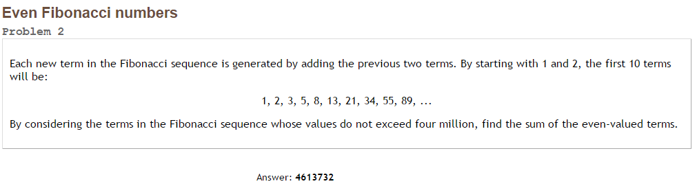Project Euler #2 – Pen & Paper Solution

Each 3rd Fibonacci number is even. We are looking for Fibonacci numbers of the form F(3n).

We know the [closed formula for Fibonacci numbers](https://en.wikipedia.org/wiki/Fibonacci_number#Relation_to_the_golden_ratio):



We need to find . To find the upper limit, we can use the inverse formula:



= [33](http://www.wolframalpha.com/input/?i=floor%28log%28%281+%2B+sqrt%285%29%29+%2F+2%2C+4000000*sqrt%285%29+%2B+0.5%29%29).

So, we need: .



= [4613732](http://www.wolframalpha.com/input/?i=%28%28%281+-+%28%281+%2B+sqrt%285%29%29+%2F+2%29%5E36%29+%2F+%281+-+%28%281+%2B+sqrt%285%29%29+%2F+2%29%5E3%29%29+-+%28%281+-+%28%281+-+sqrt%285%29%29+%2F+2%29%5E36%29+%2F+%281+-+%28%281+-+sqrt%285%29%29+%2F+2%29%5E3%29%29%29+%2F+sqrt%285%29)